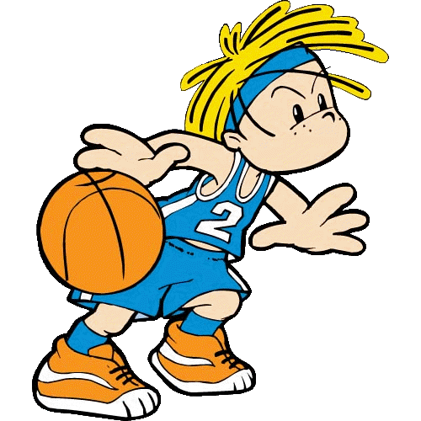
HHBC SPORTS
Parent Information:

Hickory Hill Baptist Church (HHBC) is offering Basketball for children ages 5 to 12.
⇒ We desire to provide competitiveness and teach character and fundamentals through sports. We also want to provide positive encouragement and fun for children through sports.
⇒ The cost for basketball will be $30. The cost will include a shirt, gift, practices, and 6 to 8 games.
IMPORTANT DATES:
-Coaches training will be Tuesday, September 27th at 7:00 p.m.
-Practices will start around October 1st
-Games will start in last week of October or first week of November.

General Information:
Please make sure your child has NON-Marking tennis shoes for practices and games. You may also want to purchase knee pads for your child.

Sample Outline for Practices:
-Learn and improve on skills of the game.
-Play games with the players.
-Teach and practice game strategy.
-Huddle Up time is a short devotional time.

Our Mission for HHBC Sports
^{1 Corinthians 9:19} …I have made myself a servant to all, that I might win more of them

Our Values for HHBC Sports
Share Jesus Christ.
It is our desire to share the Good News of Jesus Christ to our community.
Play Competitive Sports
It is our desire to make the teams fair with about the same skill level so that the games will be competitive.
Offer Biblical Lessons
It is our desire to offer Biblical lessons for life application.
Reach Out to Grow
It is our desire to reach out to our community and grow as a church.
Teach Character
It is our desire to teach children character through sports.
Sporting Skills Taught
It is our desire to teach the basic skills of the sport to children.

How to ensure your child has a positive experience?
-Talk with your child about what they learned in practice.
-Practice with your child.
-Be positive and encouraging.
-Encourage and help the coach if he/she needs it.
-Please be on time to practice and games.
-HHBC is learning and trying our best. If you see anything we do well, please let us know. If you see anything we can improve on, please let us know.

Guidelines for Building
Hickory Hill Baptist Church (HHBC) has built a new building for us to use.
-Please treat our new building with respect.
-No tobacco products.
-No rude behavior.
-Only wear NON-Marking shoes.
-No food or drinks on the court.
-Please stay off the field/court when games are being played.
-Please respect each other.
-Please NO running in the building with the exclusion of players.
-All children must be accompanied by an adult.

General Basketball Rules

A coin flip or other another method will determine which team receives first possession. The team will throw the ball from the sidelines to start play. At the end of 1st , 2nd , and 3rd, quarters, the team who receives the ball next is based upon the direction of the possession arrow.

Games will consist of 4 quarters. The clock will not stop unless a time out is called, the referee calls for it, foul is called, or a player is injured. The clock will stop for throw-ins and fouls in the last 2 minutes of the 2nd and 4th quarters unless one team has a large lead. Each team will have a 1 minute time out for each quarter. All four time outs can be used any time in the game.

A jump ball is also used to determine who gets possession if opposing players get tied-up with the ball. In jump ball situations, possessions will alternate.

A coach may substitute players on any dead ball situation. Players must play equal amount time and play in both halves.

Any game ending in a tie will remain a tie. No overtimes are played so games stay on schedule.

Teams will switch goals at half-time. Younger kids do not have to switch goal at half-time.

A foul on a shot will result in free throws awarded to the player who was fouled. If the player was shooting inside the 3 point line, then 2 free throws will be awarded. If the second free throw is missed, the ball becomes a live ball. If the player was shooting on or outside the 3 point line, then he or she will receive 3 free throws. If the player misses the 3rd free throw, then the ball is a live ball.

A technical or flagrant foul on a player, coach, or spectator may be called at the discretion of the referee. The foul will result in 2 free throws for the opposing team, possession of the ball after free throws, and the possession arrow being reset to their favor. If another technical foul is called then that person will be ejected from the game and other consequences will follow for their behavior.

Defense:
Man-to-man and Zone defense are allowed. HHBC prefers man-to-man defense because it will improve player’s skill. Defense must stay within arm’s reach of the player they are guarding.

Full court presses are not allowed in the younger teams. Defensive players may not guard their opponents in the backcourt. The older teams may do a full court press or guard in the back court only in the last 2 minutes of the 2nd and 4th quarter.

Offense:
The offense must attack the defensive—no stalling is allowed. After a warning from the referee, a violation will be called resulting in a turnover. This will prevent a team with the lead from running the clock out by staying in the backcourt.

No score will be given for a basket in the wrong goal. It will be treated as a turnover.

EXTRA STUFF:
-If a team gets a big lead, they may not receive any points until the other team catches up.

-Please be considerate to the referees. They are volunteering their time to help us. They will not see every foul and will not call every foul.

MODIFICATIONS FOR YOUNGER PLAYERS

-3-second violation is not called.

-Free throws are awarded on all shooting fouls.

-Violation resulting in a turnover will not be called for double dribbling and traveling. The referee will stop play for these violations and explain the violation. Players will be able to shuffle their feet a little to shoot the ball.

-When a player is getting too rough and fouling, the referee will explain the foul. After a player receives their 5th personal foul, they must sit out at least a quarter of the rest of the game. After the foul is explained by referee to the players, the ball is given to the team that received the foul. There is no shooting free throws for personal fouls.

-Defensives can not guard the offense until they reach 10 foot volleyball line (white line close to the 3 foot arch).

- Ages 5-7 will use a 6 foot goal and 25.5” basketball and each quarter will be 6 minutes long.

- Ages 8-10 will use a 8 foot goal and 25.5” basketball and each quarter will be 7 minutes long.
MOIFICATIONS FOR OLDER PLAYERS

-Will use a 10 foot goal and 28.5” basketball.

-Each quarter will be 8 minutes long.

-3-second violation will be called.

-Fouls that will be called: traveling, double dribbling, pushing, tripping, grabbing, reaching in on the ball, and fouls on a shot.

-Defense can start guarding the offense at half court. They can guard in back court in the last 2 minutes of the 2nd and 4th quarter.

-When a team receives their 7th collective foul in a half, the opposing team will enter the “bonus” and receive a free throw. If that free throw is missed, the basketball will be considered a live ball. If that free throw is made, a second free throw is awarded. If the second free throw is missed, the basketball is a live ball. If the free throw is made, the ball will switch possessions under the goal.

-When a team receives their 10th collective foul in a half, the opposing team will enter the “double bonus” and receive two free throws. If the second free throw is missed the ball will be considered a live ball. If the free throw is made, the ball will switch possessions under the goal.

-Any player who receives their 5th foul will sit out the rest of the game.

